**Brandes’ Algorithm for Betweenness Centrality of a Graph**

In the extra task of the course, the students are required to implement the following algorithm and show its output on the following graph. For the submission, the students are required to submit a video recording of their demo. The deadline to submit the task is 24th June at 5:00 PM.

The betweenness centrality of a vertex x of a graph G(V, E) is the sum over all pairs of vertices y, z in the graph of the number of shortest paths (Px y,z) from y to z that pass through x divided by the number of all the shortest paths from y to z. More precisely, the betweenness centrality of a vertex x is:

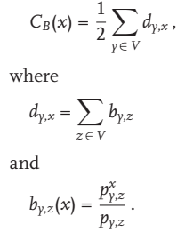

This measure is suggested by the sociology of networks of individuals, so called “social networks.” In addition, it captures important structural features of a graph, making it quite useful in approximating orbits. The algorithm and the required graph is as follows:

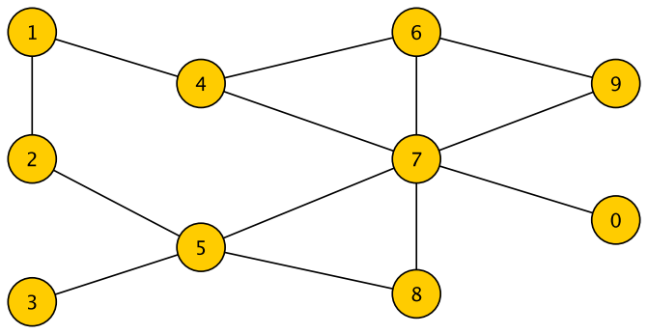

Figure : The graph to run Brandes' Algorithm

